# PRACTICAL 1

## PROGRAM 1:

**#Program to calculate the area of circle, triangle and rectangle**

def areacalculator():

_input_ = input("Enter the shape you want to calculate area of: ")

area = 0

pie = 3.14

if _input_ == "Circle":

radius = int(input("Enter the value of radius: "))

area = area + (2 * pie * radius)

elif _input_ == "Rectangle":

length = int(input("Enter the value of length: "))

width = int(input("Enter the value of length: "))

area = area + (length * width)

elif _input_ == "Triangle":

base = int(input("Enter the value of base: "))

height = int(input("Enter the value of height: "))

area = area +(0.5 * base * height)

else:

print ("Select a valid shape")

print ("%.2f" % area)

areacalculator()

-------------------------------------------------------------------------------------------------------------------

**OUTPUT:**

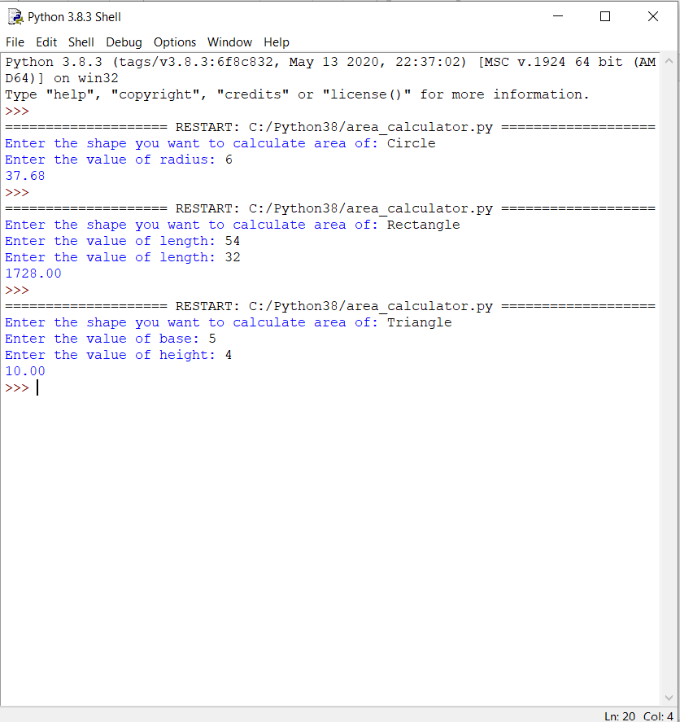

## PROGRAM 2:

#Program to add two numbers and take input from the user.

number1 = input("First number: ")

number2 = input("\n Second number: ")

# Adding two numbers

# User might also enter float numbers

sum = float(number1) + float(number2)

# Display the sum

# will print value in float

print("The sum of {0} and {1} is {2}" .format(number1, number2, sum))

**------------------------------------------------------------------------------------------------------------------**

**OUTPUT:**

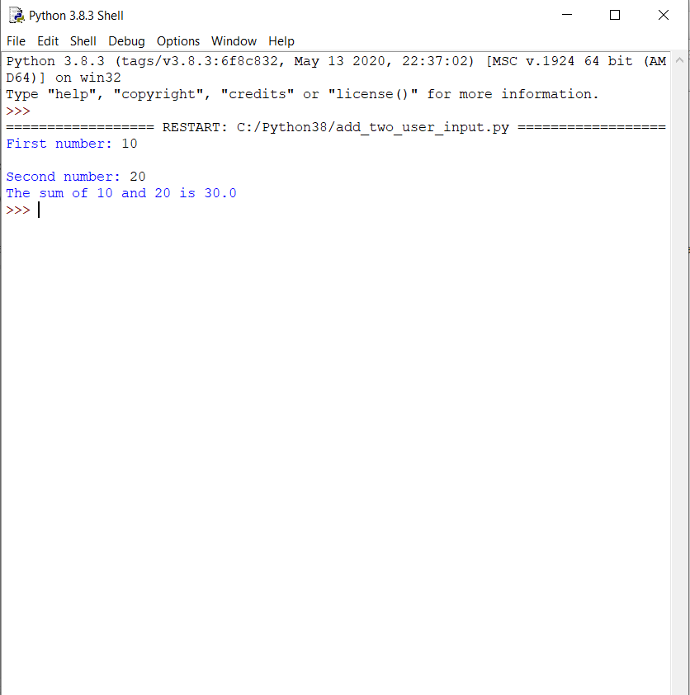

## PROGRAM 3:

#Program to show the use of “eval()” function

from math import *

def secret_function():

return "Secret key is 1234"

def function_creator():

# expression to be evaluated

expr = input("Enter the function(in terms of x):")

# variable used in expression

x = int(input("Enter the value of x:"))

# evaluating expression

y = eval(expr)

# printing evaluated result

print("y = {}".format(y))

if __name__ == "__main__":

function_creator()

-------------------------------------------------------------------------------------------------------------------

**OUTPUT:**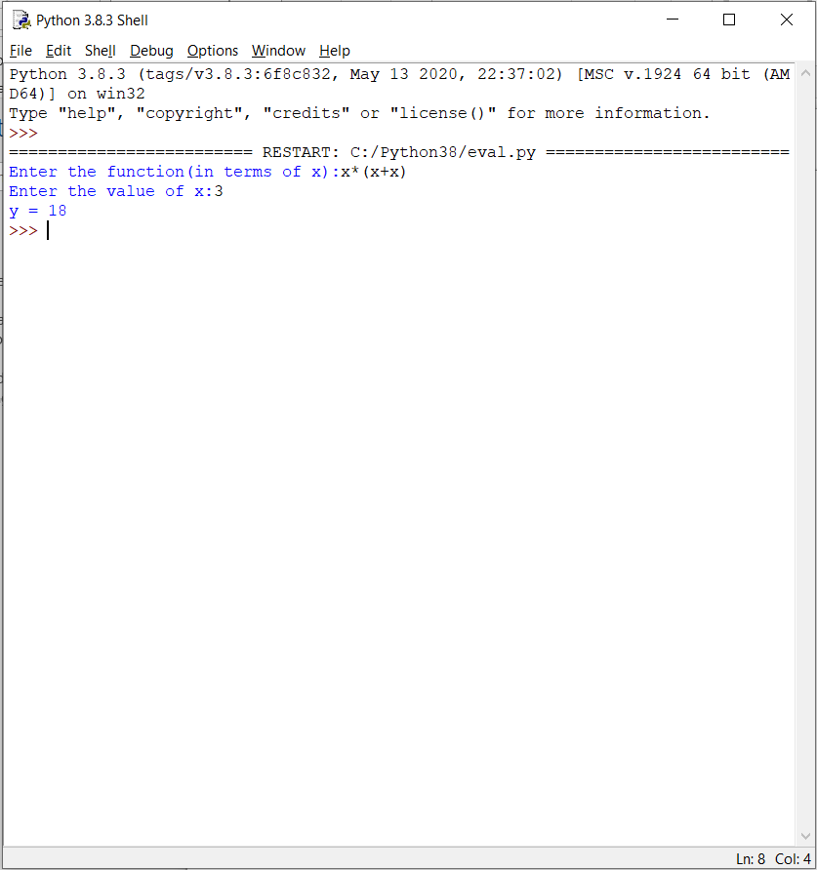

## PROGRAM 4:

#Program to convert days into months and days.

n=int(input("Please enter Number of Days In a year"))

#Average days in a month taken as 30

month=int(n/30)

days= n % 30

print("month=",month,"\n days=",days)

-------------------------------------------------------------------------------------------------------------------

**OUTPUT:**

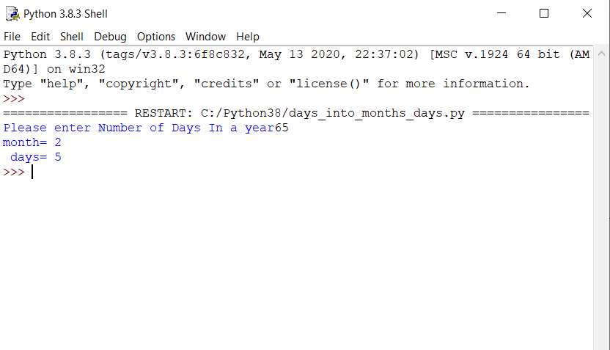

## PROGRAM 5:

#Program to check whether the number is prime or not.

num = int(input("Enter a number: "))

if num > 1:

for i in range(2,num):

if (num % i) == 0:

print(num,"is not a prime number")

break

else:

print(num,"is a prime number")

else:

print(num,"is not a prime number")

-------------------------------------------------------------------------------------------------------------------

**OUTPUT:**

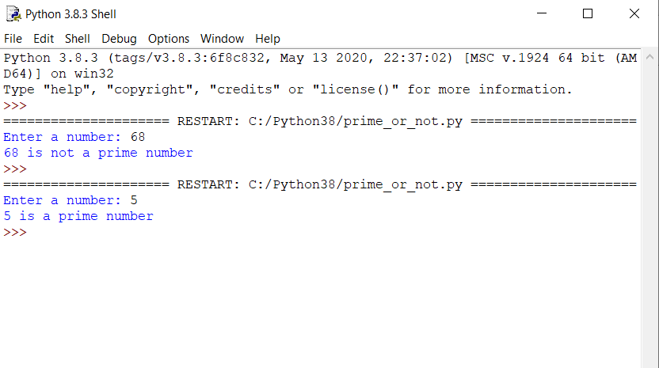

# PRACTICAL 2

## PROGRAM 1:

**#PROGRAM TO PRINT THE LARGEST NUMBER AMONG THREE**

max=0

num1=int(input("ENTER NUMBER 1:"))

num2=int(input("ENTER NUMBER 2:"))

num3=int(input("ENTER NUMBER 3:"))

if num1>num2:

if num1>num3:

max=num1

else:

max=num3

else:

if num2>num3:

max=num2

else:

max=num3

print("THE LARGEST NUMBER IS ",max)

-------------------------------------------------------------------------------------------------------------------

**OUTPUT:**

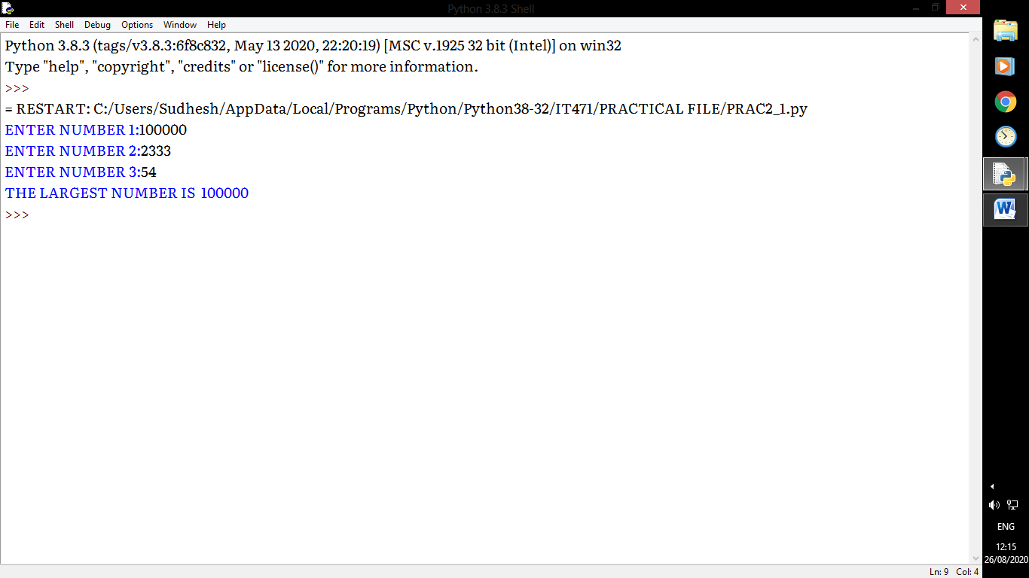

## PROGRAM 2:

**#PROGRAM TO FIND SUM OF ALL INTEGERS GREATER THAN 100 & LESS THAN** 200 AND ARE DIVISIBLE BY 5.

sum_=0

for i in range(101,200):

if i%5==0:

sum_=sum_+i

print("SUM = ",sum_)

-------------------------------------------------------------------------------------------------------------------

**OUTPUT :**

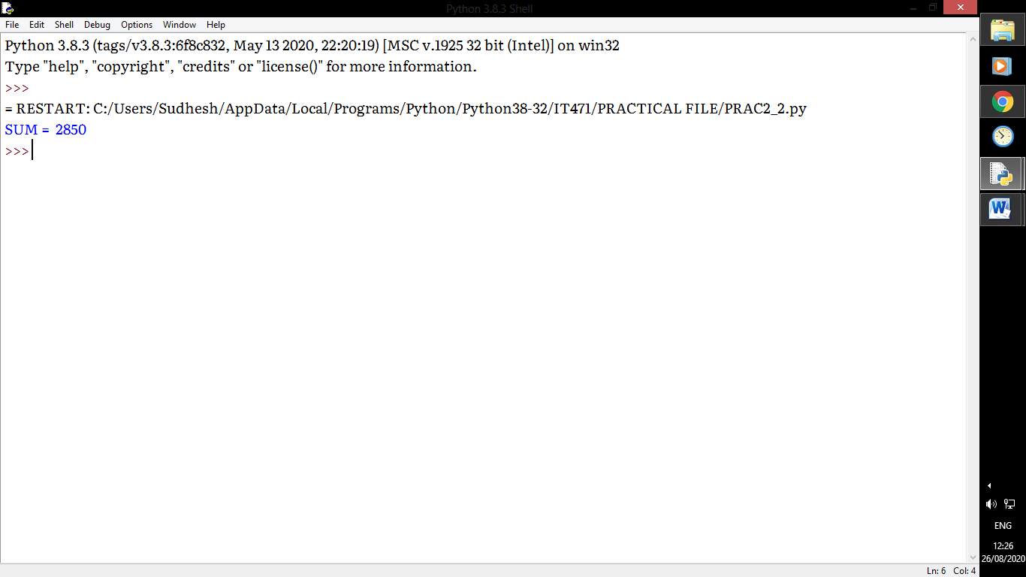

## PROGRAM 3:

**#PROGRAM TO PRINT GRADABLE MARK SHEET OF STUDENT USING elif**

sub1=int(input("ENTER THE MARKS IN SUBJECT 1:"))

sub2=int(input("ENTER THE MARKS IN SUBJECT 2:"))

sub3=int(input("ENTER THE MARKS IN SUBJECT 3:"))

sub4=int(input("ENTER THE MARKS IN SUBJECT 4:"))

sub5=int(input("ENTER THE MARKS IN SUBJECT 5:"))

mark = (sub1 + sub2 + sub3 +sub4 + sub5)/5

if mark > 90:

grade="AA"

elif mark > 80 and mark <=90:

grade="AB"

elif mark > 70 and mark<=80:

grade="BB"

elif mark >60 and mark <=70:

grade="BC"

elif mark >50 and mark <=60:

grade="CC"

elif mark>40 and mark<=50:

grade="D"

else:

grade="NEEDS IMPROVEMENT"

print("AGGREGATE MARKS (OUT OF 100) ",mark," & GRADE OF THE STUDENT IS ",grade)

------------------------------------------------------------------------------------------------------------------

**OUTPUT:**

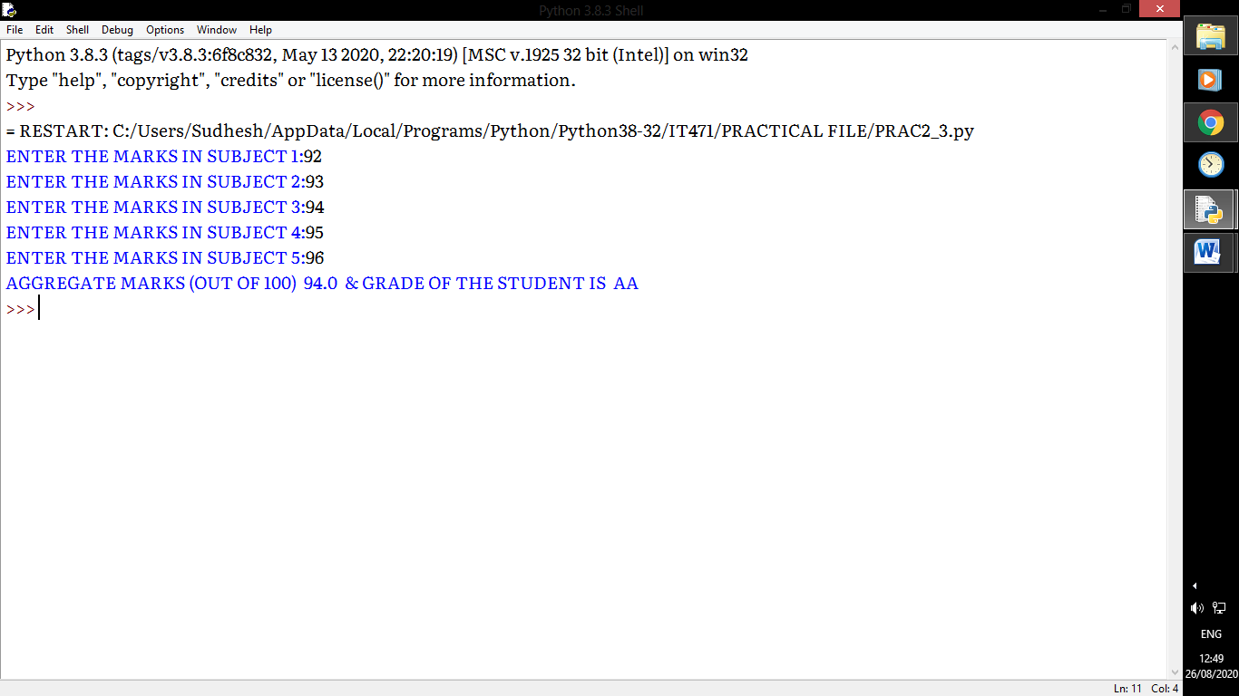

# PRACTICAL 3

## PROGRAM 1:

**#PROGRAM TO PRINT FIBONACCI SERIES OF N NUMBERS USING CONCEPT OF COMMAND LINE ARGUMENTS**

import sys

n = int(sys.argv[1])

def fibonnaci(n):

n1, n2 = 0,1

sum1,i=0,0

while i < n:

print(n1,end=" ")

sum1=n1+n2

n1=n2

n2=sum1

i+=1

fibonnaci(n)

-------------------------------------------------------------------------------------------------------------------

**OUTPUT:**

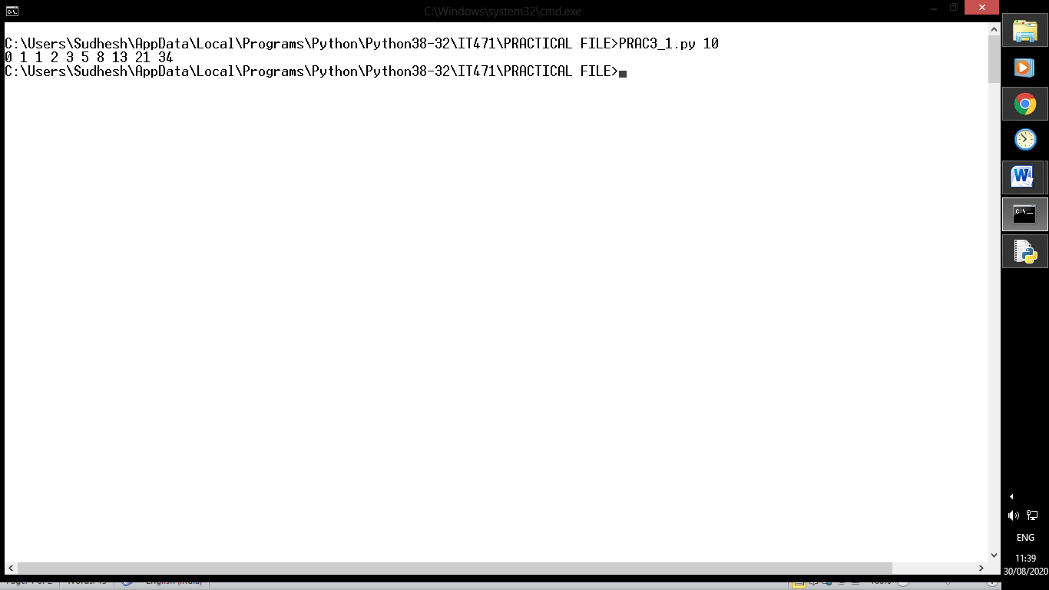

## PROGRAM 2:

**#PROGRAM TO SHOW THE USE OF CONTINUE, PASS, BREAK.**

#CONTINUE

def continue_func( s):

for i in range(len(s)):

if i==5:

print(" ",end="")

continue

print(s[i],end="")

print("\n")

'''--------------------------------------------'''

#PASS

def pass_func(s):

for i in range(len(s)):

if i==5:

print(" ",end="")

pass

print(s[i],end="")

print("\n")

'''--------------------------------------------'''

#BREAK

def break_func(s):

for i in range(len(s)):

if i==5:

print(" ",end="")

break

print(s[i],end="")

print("\n")

'''--------------------------------------------'''

s="ABANDONED"

print("ORIGINAL STRING:",s)

print("STRING AFTER CONTINUE:")

continue_func( s)

print("STRING AFTER PASS:")

pass_func(s)

print("STRING AFTER BREAK:")

break_func(s)

-------------------------------------------------------------------------------------------------------------------

**OUTPUT:**

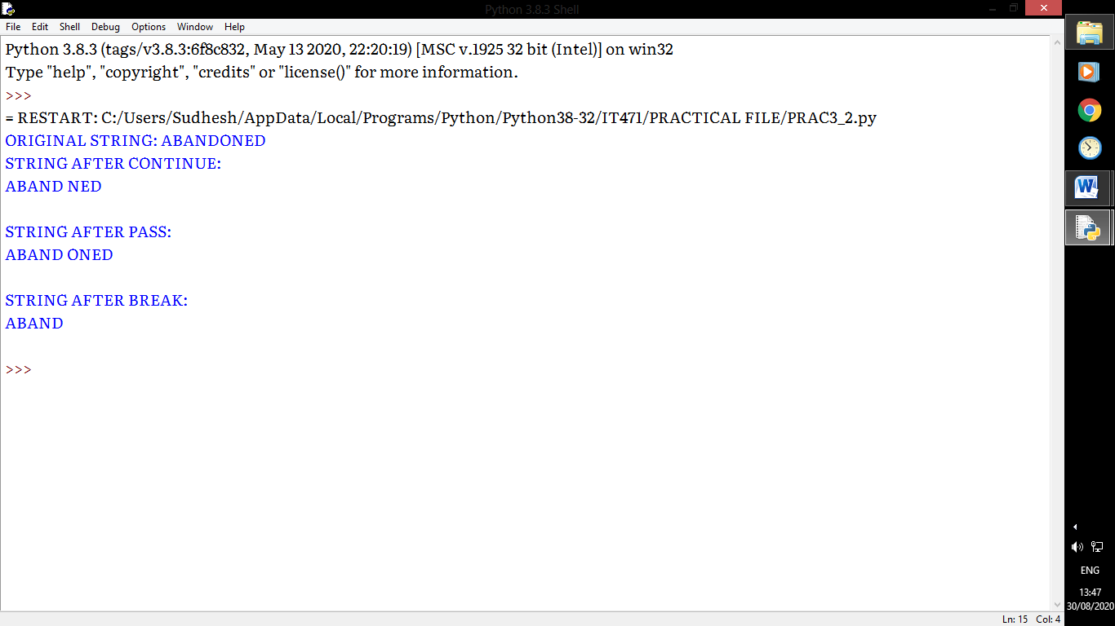

## PROGRAM 3:

**#PROGRAM TO PRINT PATTERN**

n=int(input("ENTER LIMIT:"))

for i in range(0,n):

for k in range(n-i-2,-1,-1):

print(" ",end="")

for j in range(0,i*2+1):

print("*",end="")

for k in range(n-i-2,-1,-1):

print(" ",end="")

print("")

**------------------------------------------------------------------------------------------------------------------**

**OUTPUT:**

